`

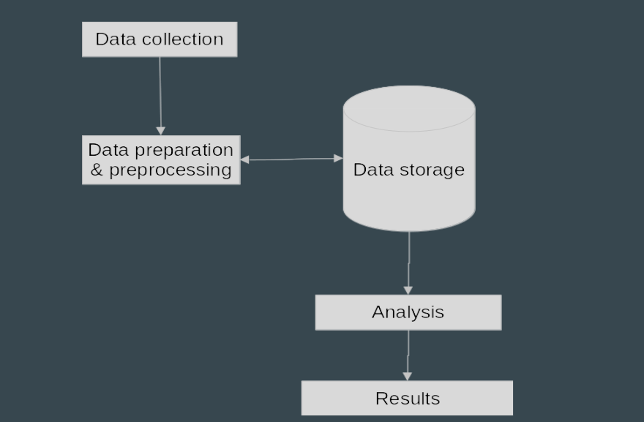

**SURVEY OF CLIMATE CHANGE**

**Part 1 of our analysis focuses on the actual phenomenon of climate change. The effects of climate change can be seen in the increase in global surface temperature, rising sea levels and increasingly frequent extreme weather events .**

**Part 2 of our analysis is based on people's attitudes towards climate change. A lot of people truly believe that the idea of climate change is a hoax or are in denial and this is a real problem. The only way to curb climate change is to get people to change their attitudes and transition to a more sustainable lifestyle.**

* PYTHON 3.7.X
* MATPLOTLIB
* PANDAS
* SKLEARN
* SEABOARN
* R STUDIO
* TABLEAU

**Global climate change, judging from the debate on the subject itself, is one of the major concerns of the world today. Global warming and its effects on Earth's weather patterns are both part of climate change.Priorities for climate action  differs significantly across countries and across sectors.Those who have been watching the issue closely, however, are concerned that it has resulted in more panic than meaningful measures for mitigating and adapting to global change.Despite the uncertainty of expected changes, action is required**

x AXXXXXX XXXXXXXXXXXXX XXXXXXXXXXXXXXXXXXXX XXXXXXXXXXX XXXXXXXXXX XXXXXXX XXXXXXX XXXXXXXXXXXX XXXXXXXXXXXXXXX XXXXXX XXXXXX XXXXXXXXXXX XXXXXX XXXXXXXXXX XXXXXXX XXXXX XXXXX XXXXX XXXXXXXXXXXXXXXXXXXXXX XXX XXXXXXXXXX XXXXXXXXXX XXXXXXXXXX

**OBJECTIVES**

**EXPERIMENTALCODE(SAMPLES)**

School of computer science and engineering

**METHODOLOGY**

**REQUIREMENTS**

**ABSTRACT**

**PRATHAM JALAN(19BCE1341) and SHRUSHTI SINGHANIA (19BCE1566)**

**RESULTS**

